**Dear DeJean Families,**

February is Black History Month, and we are excited to celebrate the outstanding achievements of countless African Americans and recognize their central role in U.S. history. We will be proudly flying the Pan-African Flag and honoring the contributions of African Americans during our daily announcements. Additionally, we are excited to celebrate with a Black History Month Assembly on Feb. 16. The goal of the assembly is to highlight the achievements and talents of our Black students and educate all our students about the accomplishments and contributions of African Americans. The week leading up to the assembly will be the “Black Out” Spirit Week. If you would like to contribute to our celebrations this month, please reach out to the admin team. We welcome your ideas and participation!

**Academics:**

We are wrapping up our second round of I-Ready testing in Math and English. Many parents have expressed an interest in getting a copy of student scores, so we will include these in the progress report mailing going out at the end of the month. The I-Ready program also comes with personalized instruction. We encourage all students to complete a minimum of 50 minutes per week in both Math and English. Students can log on to I-Ready Intervention at home. Engaging with the program is an excellent way to build their skills and address any learning gaps they may have.

**Reminders:**

Remember to encourage your student to turn off their electronics and read for at least 20 minutes every night. Reading every day helps students build stamina, develop a stronger vocabulary, improve critical thinking, and foster writing skills. Studies show that children who read 20 minutes a night score significantly higher on standardized tests.

**Events:**

**February 6: Semester 1 Honor Roll Ceremony**

* We will be celebrating all our students who received a 3.0 GPA or above with dinner and awards. Come out to support our exceptional scholars!

**February 8: ELAC Meeting #4 at 6 pm on Zoom**

* It is almost time to start ELPAC testing for our ELD students. Come hear all the details of this exam and what you can do to help your student prepare.

**February 19 - 23: President’s Week Holiday**

* No school for students

**February 16: Coffee Chat with the Principal at 9 am**

* Come have some pastries and coffee and chat with Principal Valdez! There will also be a short presentation about vaping and campus safety.

**February 16: Black History Month Assembly**

* Our students will be honoring the contributions of African Americans.

**February 27: Mobile Dentist Clinic; Big Smiles**

* This is a chance for students to receive dental care while at school. For more information and to sign up your student, go to [www.myschooldentist.com](https://urldefense.com/v3/__https://www.myschooldentist.com/__;!!OZEuhTV5Po1-xdhMVz0!E6bE1wJfgJM2VyWpfU7VRUNLVyiBwFdUfzpmkZJEbTysk6NUkhXxo5cDJ4AZWWuQYhfpfgdndQ4J9PrhPZY-ofCyME2FHw$).

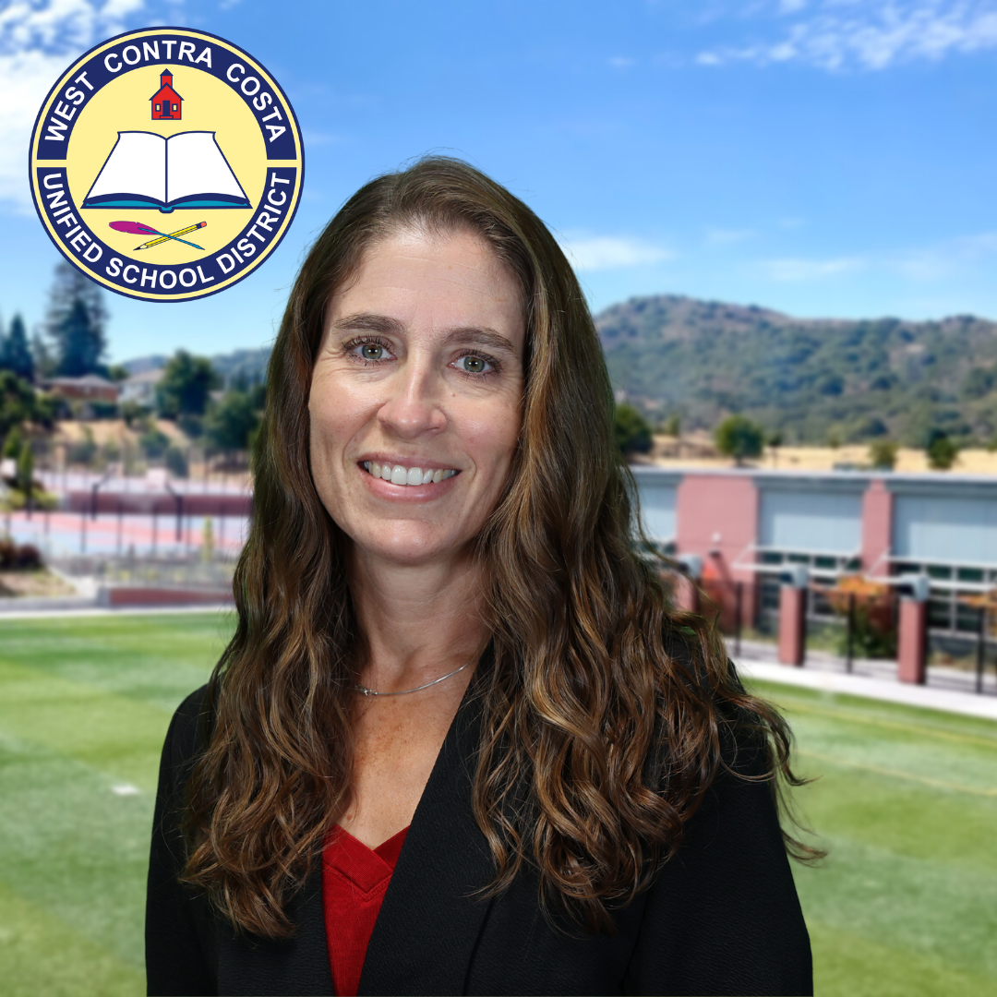

In Solidarity,

Athena Valdez

Principal